
Sec 3 Express End-of-Year Paper 1 — Marking Scheme
Worked Solutions + Marking Scheme
Cambridge Learning Group · Sec 3 Express EOY · Paper 1 · 2026
15 pages · 90 marks

How to read this booklet:
BLACK — the question, written ON the original question paper
BLUE — the full step-by-step working and the reason for each line
RED — the marking scheme: where each B1 / M1 / A1 is earned, the traps,
and the key concept the question is testing

Mark codes: B1 independent answer mark · M1 method mark (earned even if
the answer is wrong) · A1 accuracy mark (only if the method mark was earned).

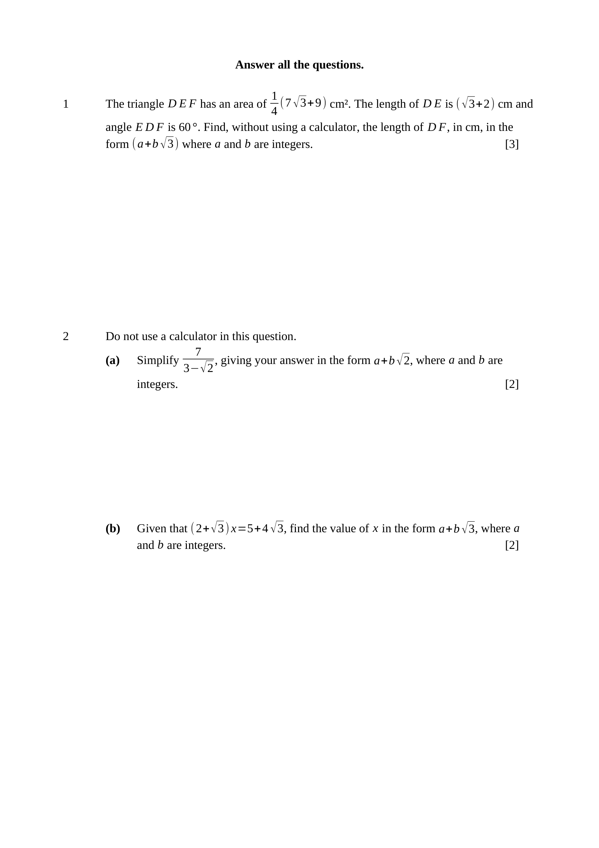
$\text{Area}=\frac{1}{2}(DE)(DF)sin{60}^{∘}$
$\frac{1}{4}\left(7\sqrt{3} + 9\right)=\frac{1}{2}\left(\sqrt{3} + 2\right)(DF)×\frac{\sqrt{3}}{2}$
$7\sqrt{3}+9=\left(3 + 2\sqrt{3}\right)(DF)$
$DF=\frac{7\sqrt{3}+9}{3+2\sqrt{3}}×\frac{3−2\sqrt{3}}{3−2\sqrt{3}}$
$DF=\frac{3\sqrt{3}−15}{−3}$
$∴DF=5−\sqrt{3}\text{ cm}$
Key concept: area with the included angle, then rationalise.
M1 – $\frac{1}{2}(DE)(DF)sin{60}^{∘}$ used, with $sin{60}^{∘}=\frac{\sqrt{3}}{2}$
M1 – multiplying by the conjugate $3−2\sqrt{3}$
A1 – $DF=5−\sqrt{3}$, so $a=5$ and $b=−1$
Note – $\left(3)^{2}−{\left(2\sqrt{3}\right)}^{2}=9−12=−3\right.$ is negative. Dropping that sign gives $\sqrt{3}−5$.
Trap – $\sqrt{3}×\sqrt{3}=3$, not $\sqrt{3}$.
$\frac{7}{3−\sqrt{2}}×\frac{3+\sqrt{2}}{3+\sqrt{2}}=\frac{7\left(3 + \sqrt{2}\right)}{9−2}$
$\frac{7\left(3 + \sqrt{2}\right)}{9−2}=\frac{7\left(3 + \sqrt{2}\right)}{7}=3+\sqrt{2}$
Key concept: multiply by the conjugate of the denominator.
M1 – conjugate $3+\sqrt{2}$ used and denominator $9−2=7$
A1 – $3+\sqrt{2}$, so $a=3$ and $b=1$
$x=\frac{5+4\sqrt{3}}{2+\sqrt{3}}×\frac{2−\sqrt{3}}{2−\sqrt{3}}$
$\text{denominator}=4−3=1$
$x=10−5\sqrt{3}+8\sqrt{3}−12$
$∴x=−2+3\sqrt{3}$
M1 – conjugate $2−\sqrt{3}$ used
A1 – $x=−2+3\sqrt{3}$, so $a=−2$ and $b=3$
Note – the denominator rationalises to exactly $1$ — the product must still be expanded.

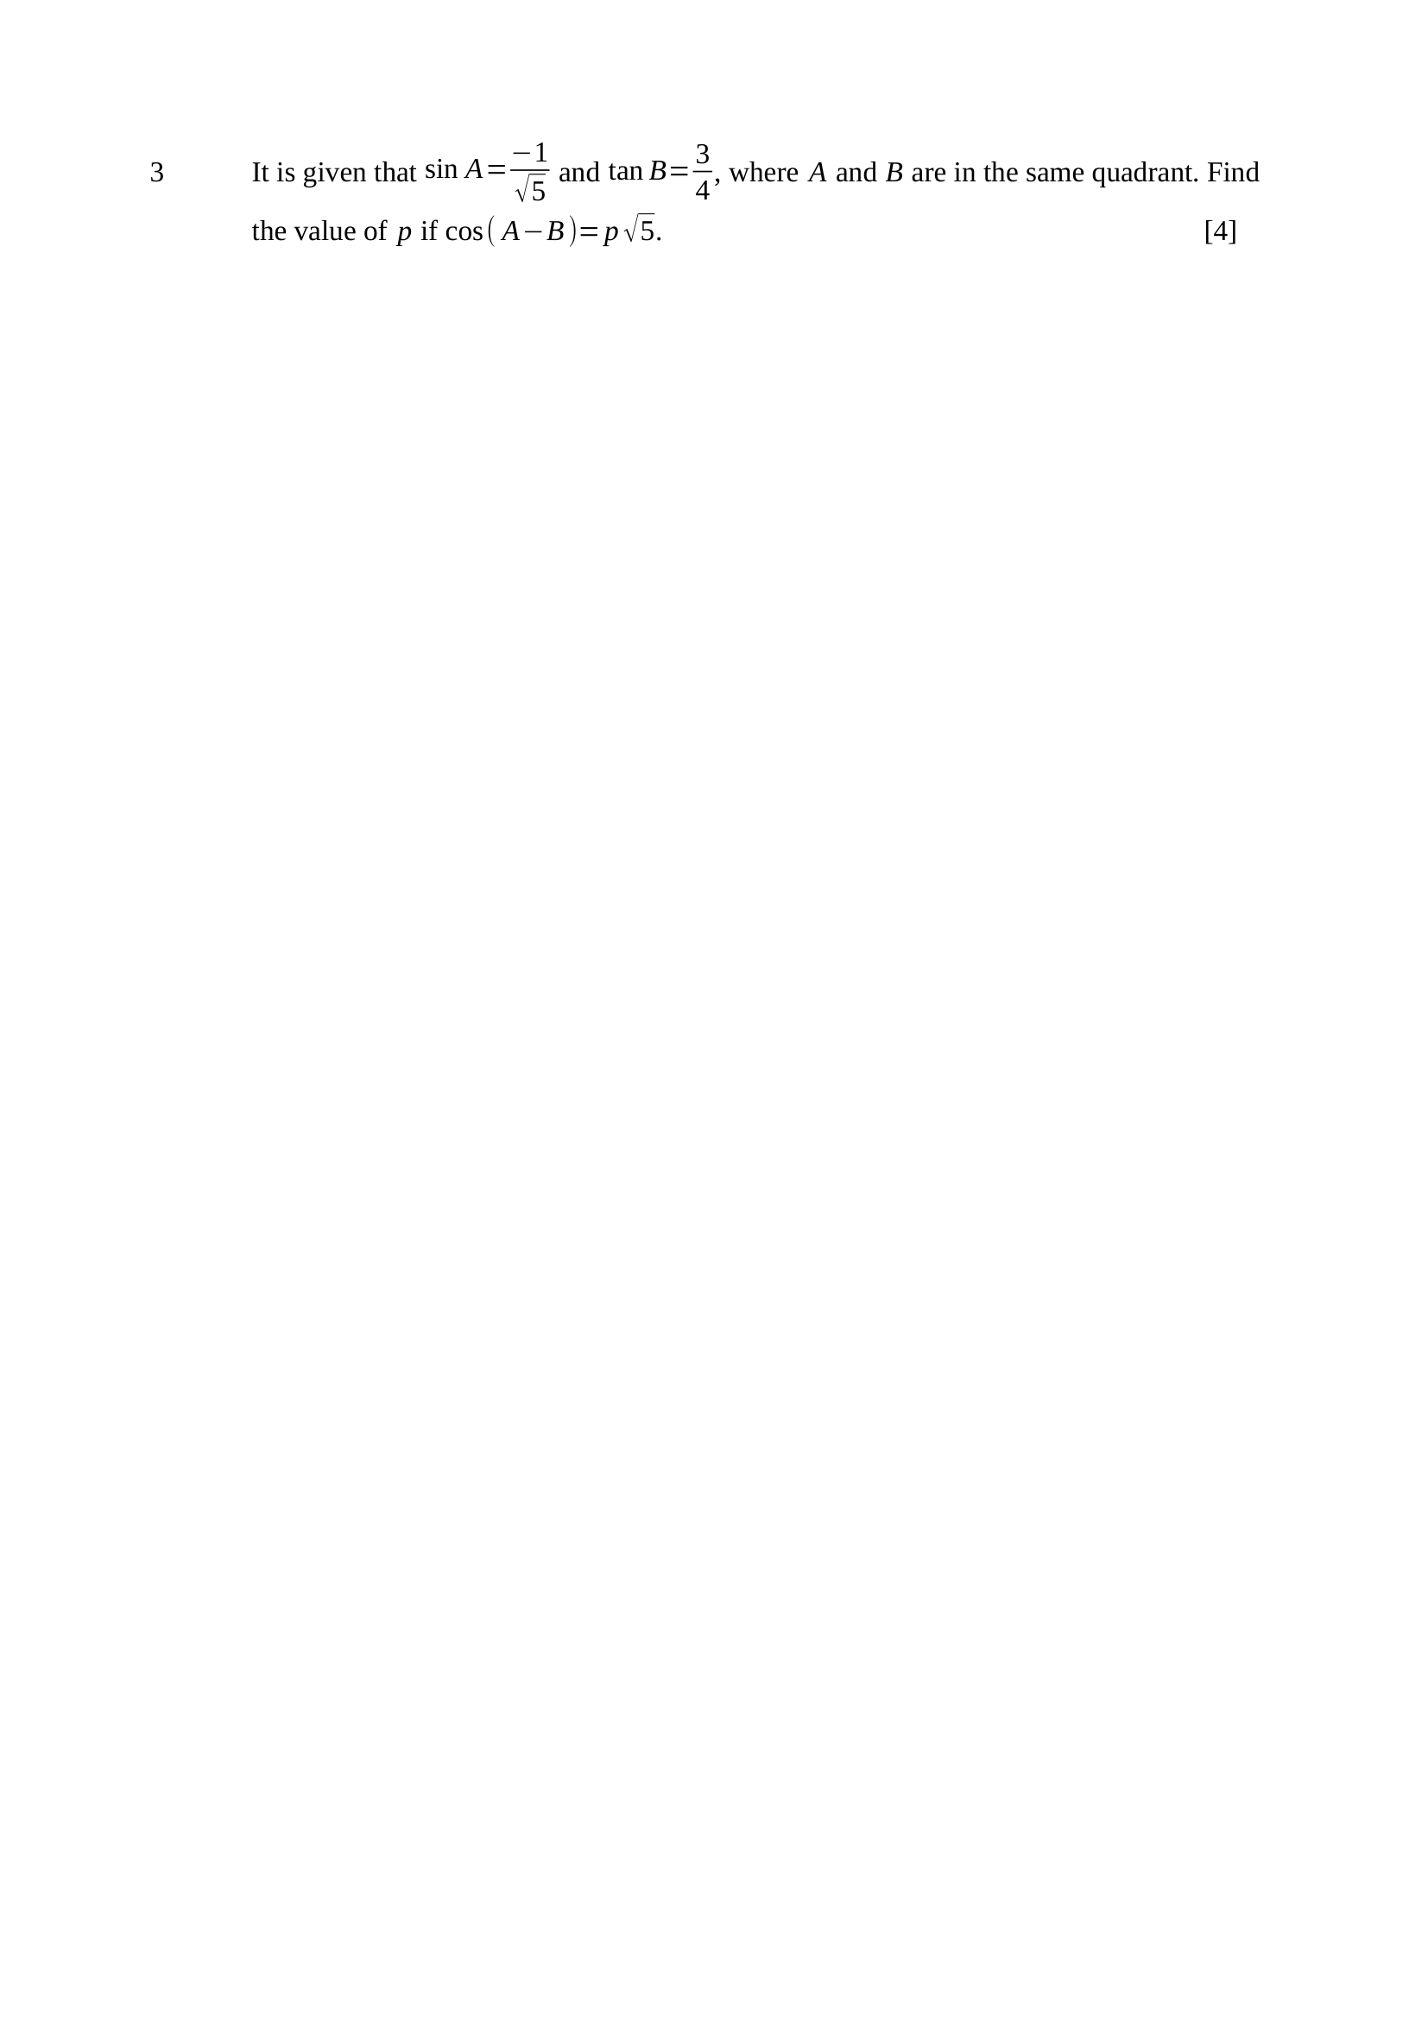
$sinA<0⇒A$ in quadrant 3 or 4
$tanB>0⇒B$ in quadrant 1 or 3
same quadrant $⇒$ both in quadrant 3
$cosA=−\frac{2}{\sqrt{5}}$
$sinB=−\frac{3}{5}, cosB=−\frac{4}{5}$
$cos(A−B)=cosAcosB+sinAsinB$
$cos(A−B)=\left( − \frac{2}{\sqrt{5}}\right)\left( − \frac{4}{5}\right)+\left( − \frac{1}{\sqrt{5}}\right)\left( − \frac{3}{5}\right)$
$cos(A−B)=\frac{11}{5\sqrt{5}}=\frac{11\sqrt{5}}{25}$
$∴p=\frac{11}{25}$
Key concept: find the quadrant first; both ratios are then negative.
B1 – both $A$ and $B$ placed in quadrant 3
B1 – $sinB=−\frac{3}{5}$ and $cosB=−\frac{4}{5}$ from the right-angled triangle with sides $3, 4, 5$
M1 – $cosAcosB+sinAsinB$ used
A1 – $p=\frac{11}{25}$
Note – a CAST diagram alone earns the first B1 only — the ratios must be written down.

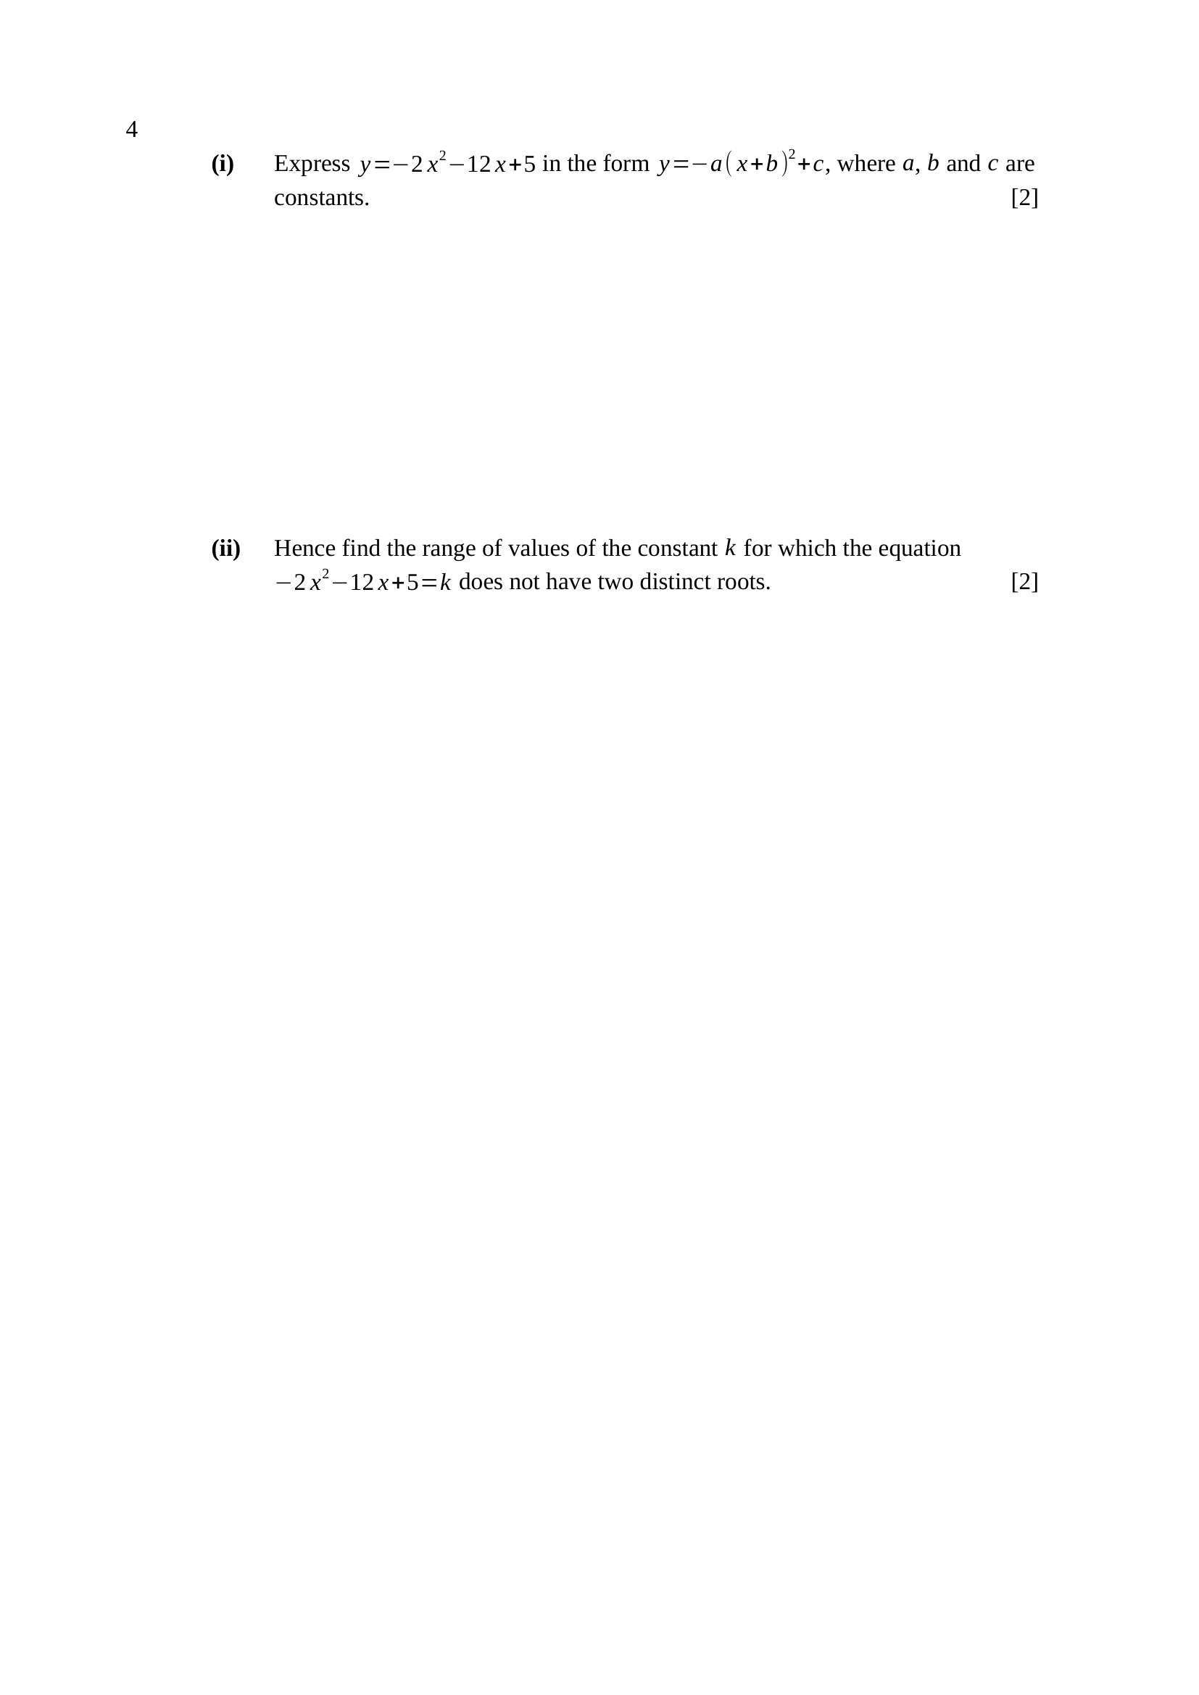
$−2x^{2}−12x+5=−2\left(x^{2} + 6x\right)+5$
$−2\left(x^{2} + 6x\right)+5=−2\left[(x+3)^{2}−9\right]+5$
$−2\left[(x+3)^{2}−9\right]+5=−2(x+3)^{2}+18+5$
$∴y=−2(x+3)^{2}+23$
M1 – $−2$ factorised out and the square completed inside
A1 – $a=2, b=3, c=23$
$−2(x+3)^{2}+23=k$
$\left(x+3)^{2}=\frac{23−k}{2}\right.$
two distinct roots need $\frac{23−k}{2}>0$
none when $\frac{23−k}{2}≤0$
$∴k≥23$
Key concept: equal roots are not two distinct roots, so the boundary is included.
M1 – $b^{2}−4ac≤0$ or $\left(x+3)^{2}≤0\right.$ used
A1 – $k≥23$
Note – by discriminant: $2x^{2}+12x+(k−5)=0$ gives $184−8k≤0$.
Trap – writing $k>23$ loses the A1.

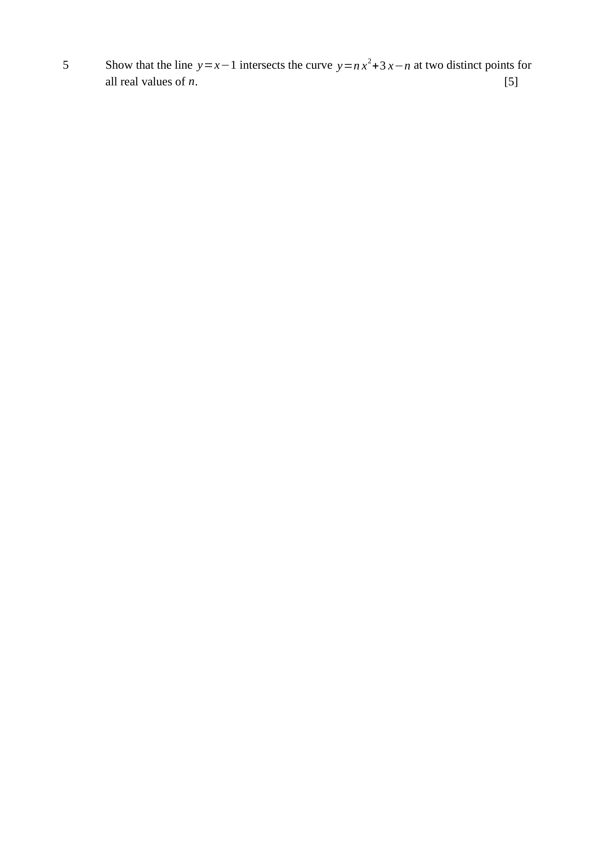
$x−1=nx^{2}+3x−n$
$nx^{2}+2x+(1−n)=0$
$\text{discriminant}=2^{2}−4(n)(1−n)$
$\text{discriminant}=4−4n+4n^{2}=4\left(n^{2}−n+1\right)$
$n^{2}−n+1={\left(n − \frac{1}{2}\right)}^{2}+\frac{3}{4}$
${\left(n − \frac{1}{2}\right)}^{2}≥0$, so $n^{2}−n+1≥\frac{3}{4}>0$
discriminant is positive for all real $n$, so the line meets the curve at two distinct points.
Key concept: show the discriminant is POSITIVE, not merely non-zero.
M1 – the two equations set equal
A1 – $nx^{2}+2x+(1−n)=0$
M1 – discriminant $4\left(n^{2}−n+1\right)$ formed
M1 – square completed, or discriminant of $n^{2}−n+1$ shown to be $−3<0$
A1 – concludes $\text{discriminant}>0$, hence two distinct points
Note – asserting positivity without justification scores the M marks only.

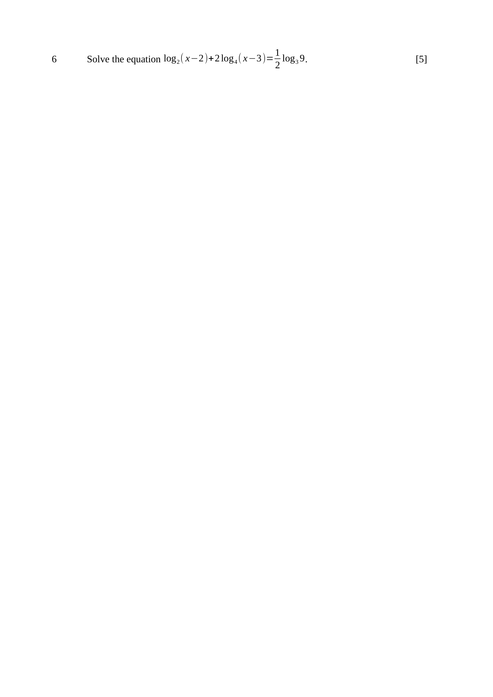
$\log_{3}9=2$, so $\text{RHS}=\frac{1}{2}×2=1$
$2\log_{4}(x−3)=\frac{2\log_{2}(x−3)}{\log_{2}4}=\log_{2}(x−3)$
$\log_{2}\left[(x−2)(x−3)\right]=1$
$(x−2)(x−3)=2$
$x^{2}−5x+4=0$
$(x−1)(x−4)=0$
$x=1$ or $x=4$
need $x−2>0$ and $x−3>0$, so $x>3$
$∴x=4$
Key concept: change base to 2, combine, then test the domain.
B1 – $\text{RHS}=1$
M1 – $\log_{4}$ changed to base 2
M1 – logs combined and the equation made quadratic
A1 – $x=1$ and $x=4$
A1 – $x=1$ rejected because $x>3$; $x=4$
Trap – rejecting with $x>0$ is not a reason — $x=1$ satisfies it.

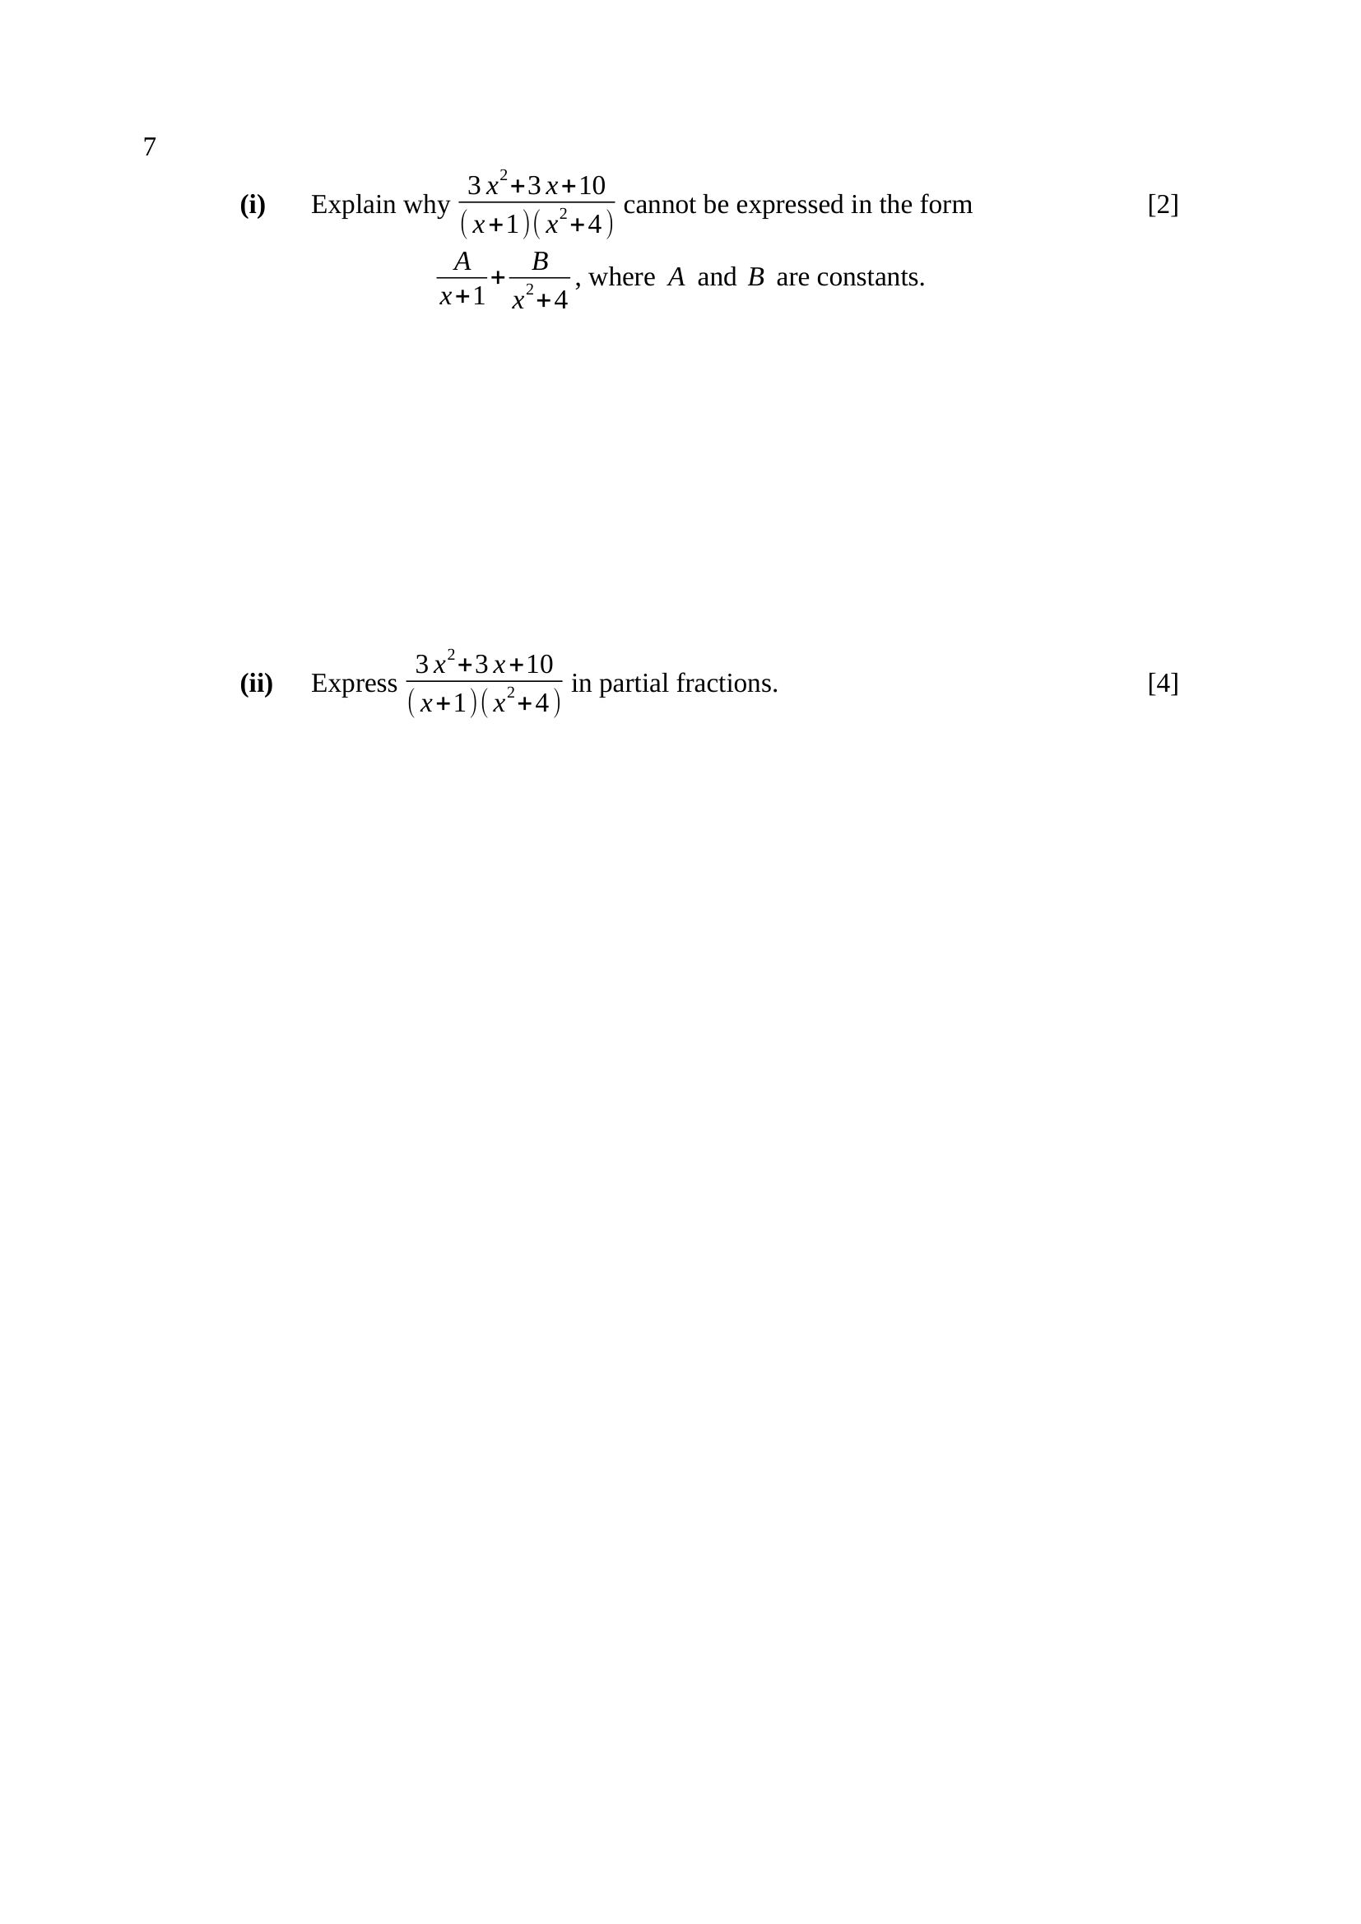
$x^{2}+4$ is an irreducible quadratic — $x^{2}=−4$ has no real root, so it has no real linear factor.
A factor of degree $2$ needs a numerator of degree $1$, i.e. $Bx+C$.
With only $A$ and $B$ there are $2$ unknowns but $3$ coefficients to match.
B1 – states $x^{2}+4$ is irreducible / has no real linear factors
B1 – states the numerator over $x^{2}+4$ must be linear, $Bx+C$
Note – writing the correct form without a reason earns the second B1 only.
$\frac{3x^{2}+3x+10}{(x+1)\left(x^{2} + 4\right)}=\frac{A}{x+1}+\frac{Bx+C}{x^{2}+4}$
$3x^{2}+3x+10=A\left(x^{2} + 4\right)+(Bx+C)(x+1)$
$x=−1$: $10=5A$, so $A=2$
compare $x^{2}$: $3=A+B$, so $B=1$
compare constants: $10=4A+C$, so $C=2$
$∴\frac{2}{x+1}+\frac{x+2}{x^{2}+4}$
M1 – correct form with $Bx+C$ written down
M1 – $x=−1$ substituted to give $A=2$
A1 – $B=1$
A1 – $C=2$
Note – check: $2\left(x^{2} + 4\right)+(x+2)(x+1)=3x^{2}+3x+10$.

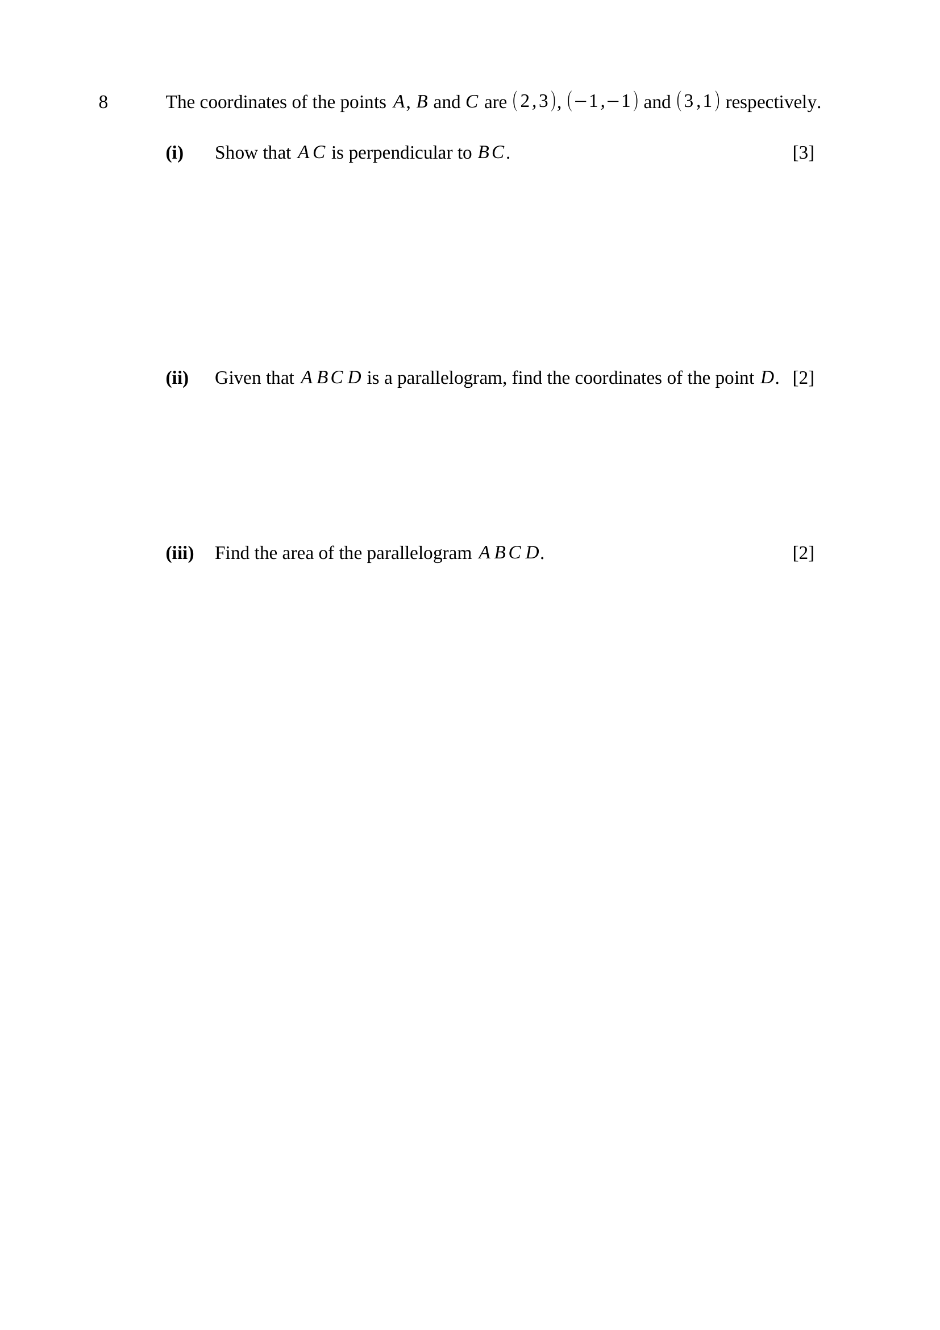
$m_{AC}=\frac{1−3}{3−2}=−2$
$m_{BC}=\frac{1−(−1)}{3−(−1)}=\frac{2}{4}=\frac{1}{2}$
$m_{AC}×m_{BC}=−2×\frac{1}{2}=−1$
$∴AC$ is perpendicular to $BC$.
M1 – $m_{AC}=−2$
M1 – $m_{BC}=\frac{1}{2}$
A1 – $\text{product}=−1$ and the conclusion stated
diagonals bisect: $\text{midpoint }AC=\text{midpoint }BD$
midpoint $AC=\left(\frac{5}{2} , 2\right)$
$\frac{−1+x_{D}}{2}=\frac{5}{2}, \frac{−1+y_{D}}{2}=2$
$∴D(6, 5)$
M1 – $\text{midpoint }AC=\text{midpoint }BD$ used
A1 – $D(6, 5)$
Trap – $\text{midpoint }AB=\text{midpoint }DC$ is false — those are opposite sides.
right angle at $C$, so $\text{area}=2×\frac{1}{2}(AC)(BC)$
$AC=\sqrt{1^{2}+(−2)^{2}}=\sqrt{5}$
$BC=\sqrt{4^{2}+2^{2}}=2\sqrt{5}$
$\text{area}=\sqrt{5}×2\sqrt{5}=10$ units${}^{2}$
M1 – a correct area method (perpendicular sides, or the shoelace formula)
A1 – $10$ units${}^{2}$
Note – part (i) makes $AC⟂BC$ available — that is the short route.

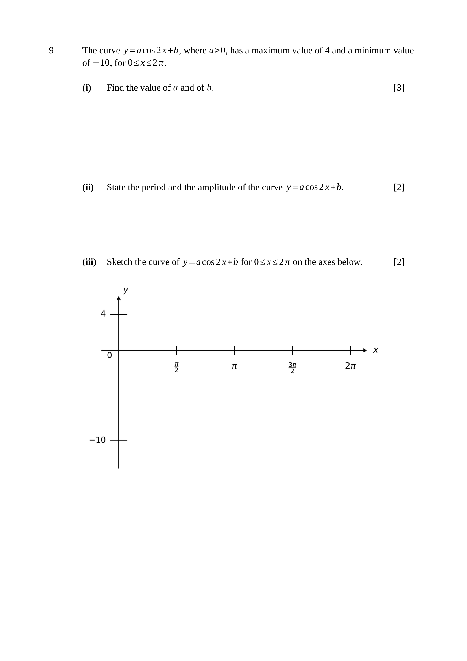
maximum: $a+b=4$
minimum: $−a+b=−10$
adding: $2b=−6$, so $b=−3$
$∴a=7, b=−3$
M1 – both $a+b=4$ and $−a+b=−10$ formed
A1 – $b=−3$
A1 – $a=7$
$\text{period}=\frac{2π}{2}=π$
$\text{amplitude}=7$
B1 – period $π$
B1 – amplitude $7$
Trap – the amplitude is $a=7$, not $14$, and $b$ does not change it.
$y=7cos2x−3$: cosine shape, $2$ complete cycles on $0≤x≤2π$
maximum $4$ at $x=0, π, 2π$; minimum $−10$ at $x=\frac{π}{2}, \frac{3π}{2}$
oscillates about $y=−3$, crossing it at $x=\frac{π}{4},\frac{3π}{4},\frac{5π}{4},\frac{7π}{4}$
B1 – correct shape, starting at a maximum, $2$ equal cycles
B1 – maximum $4$ and minimum $−10$ shown at the right values of $x$

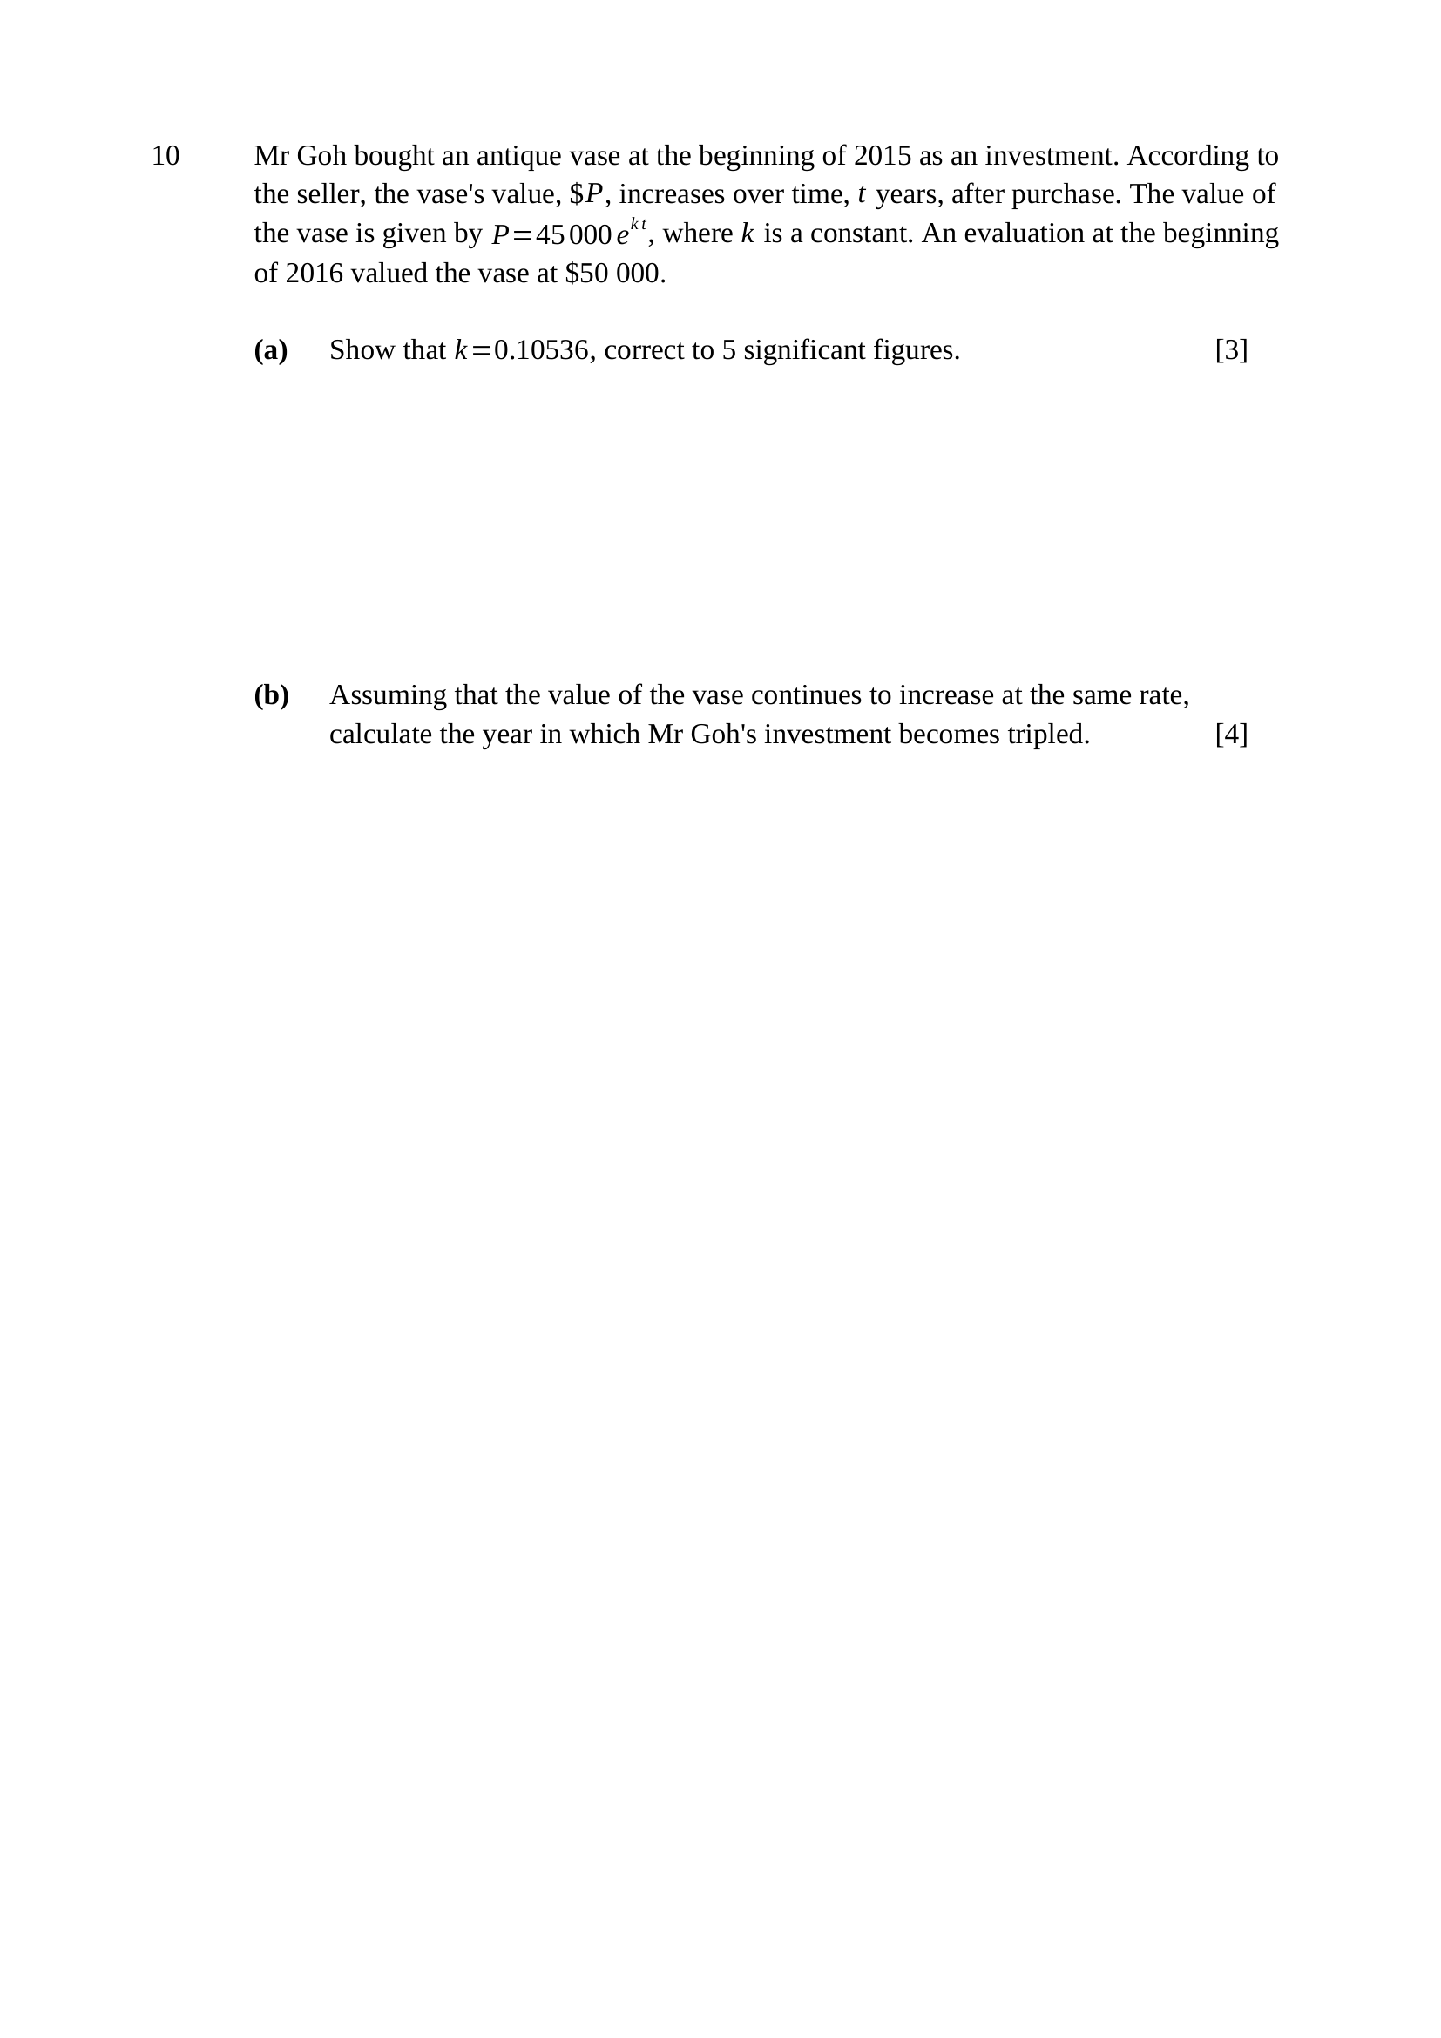
$t=1, P=50 000$:
$50 000=45 000e^{k}$
$e^{k}=\frac{50 000}{45 000}=\frac{10}{9}$
$k=ln\frac{10}{9}=0.1053605…$
$∴k=0.10536$ ($5$ s.f.)
M1 – $t=1$ and $P=50 000$ substituted
M1 – $e^{k}=\frac{10}{9}$
A1 – $k=0.10536$ correct to $5$ s.f.
tripled: $P=3×45 000=135 000$
$135 000=45 000e^{kt}$
$e^{kt}=3$
$t=\frac{ln3}{0.1053605}=\frac{1.098612}{0.1053605}$
$t=10.427…≈10.43$ years
$10.43$ years after the start of $2015$ falls in $2025$.
Key concept: triple the ORIGINAL investment, then read off the calendar year.
M1 – $P=3×45 000=135 000$
M1 – $e^{kt}=3$
M1 – $t=\frac{ln3}{k}$
A1 – the year $2025$
Trap – tripling the $\$50 000$ valuation, or stopping at $t=10.4$ without naming the year.

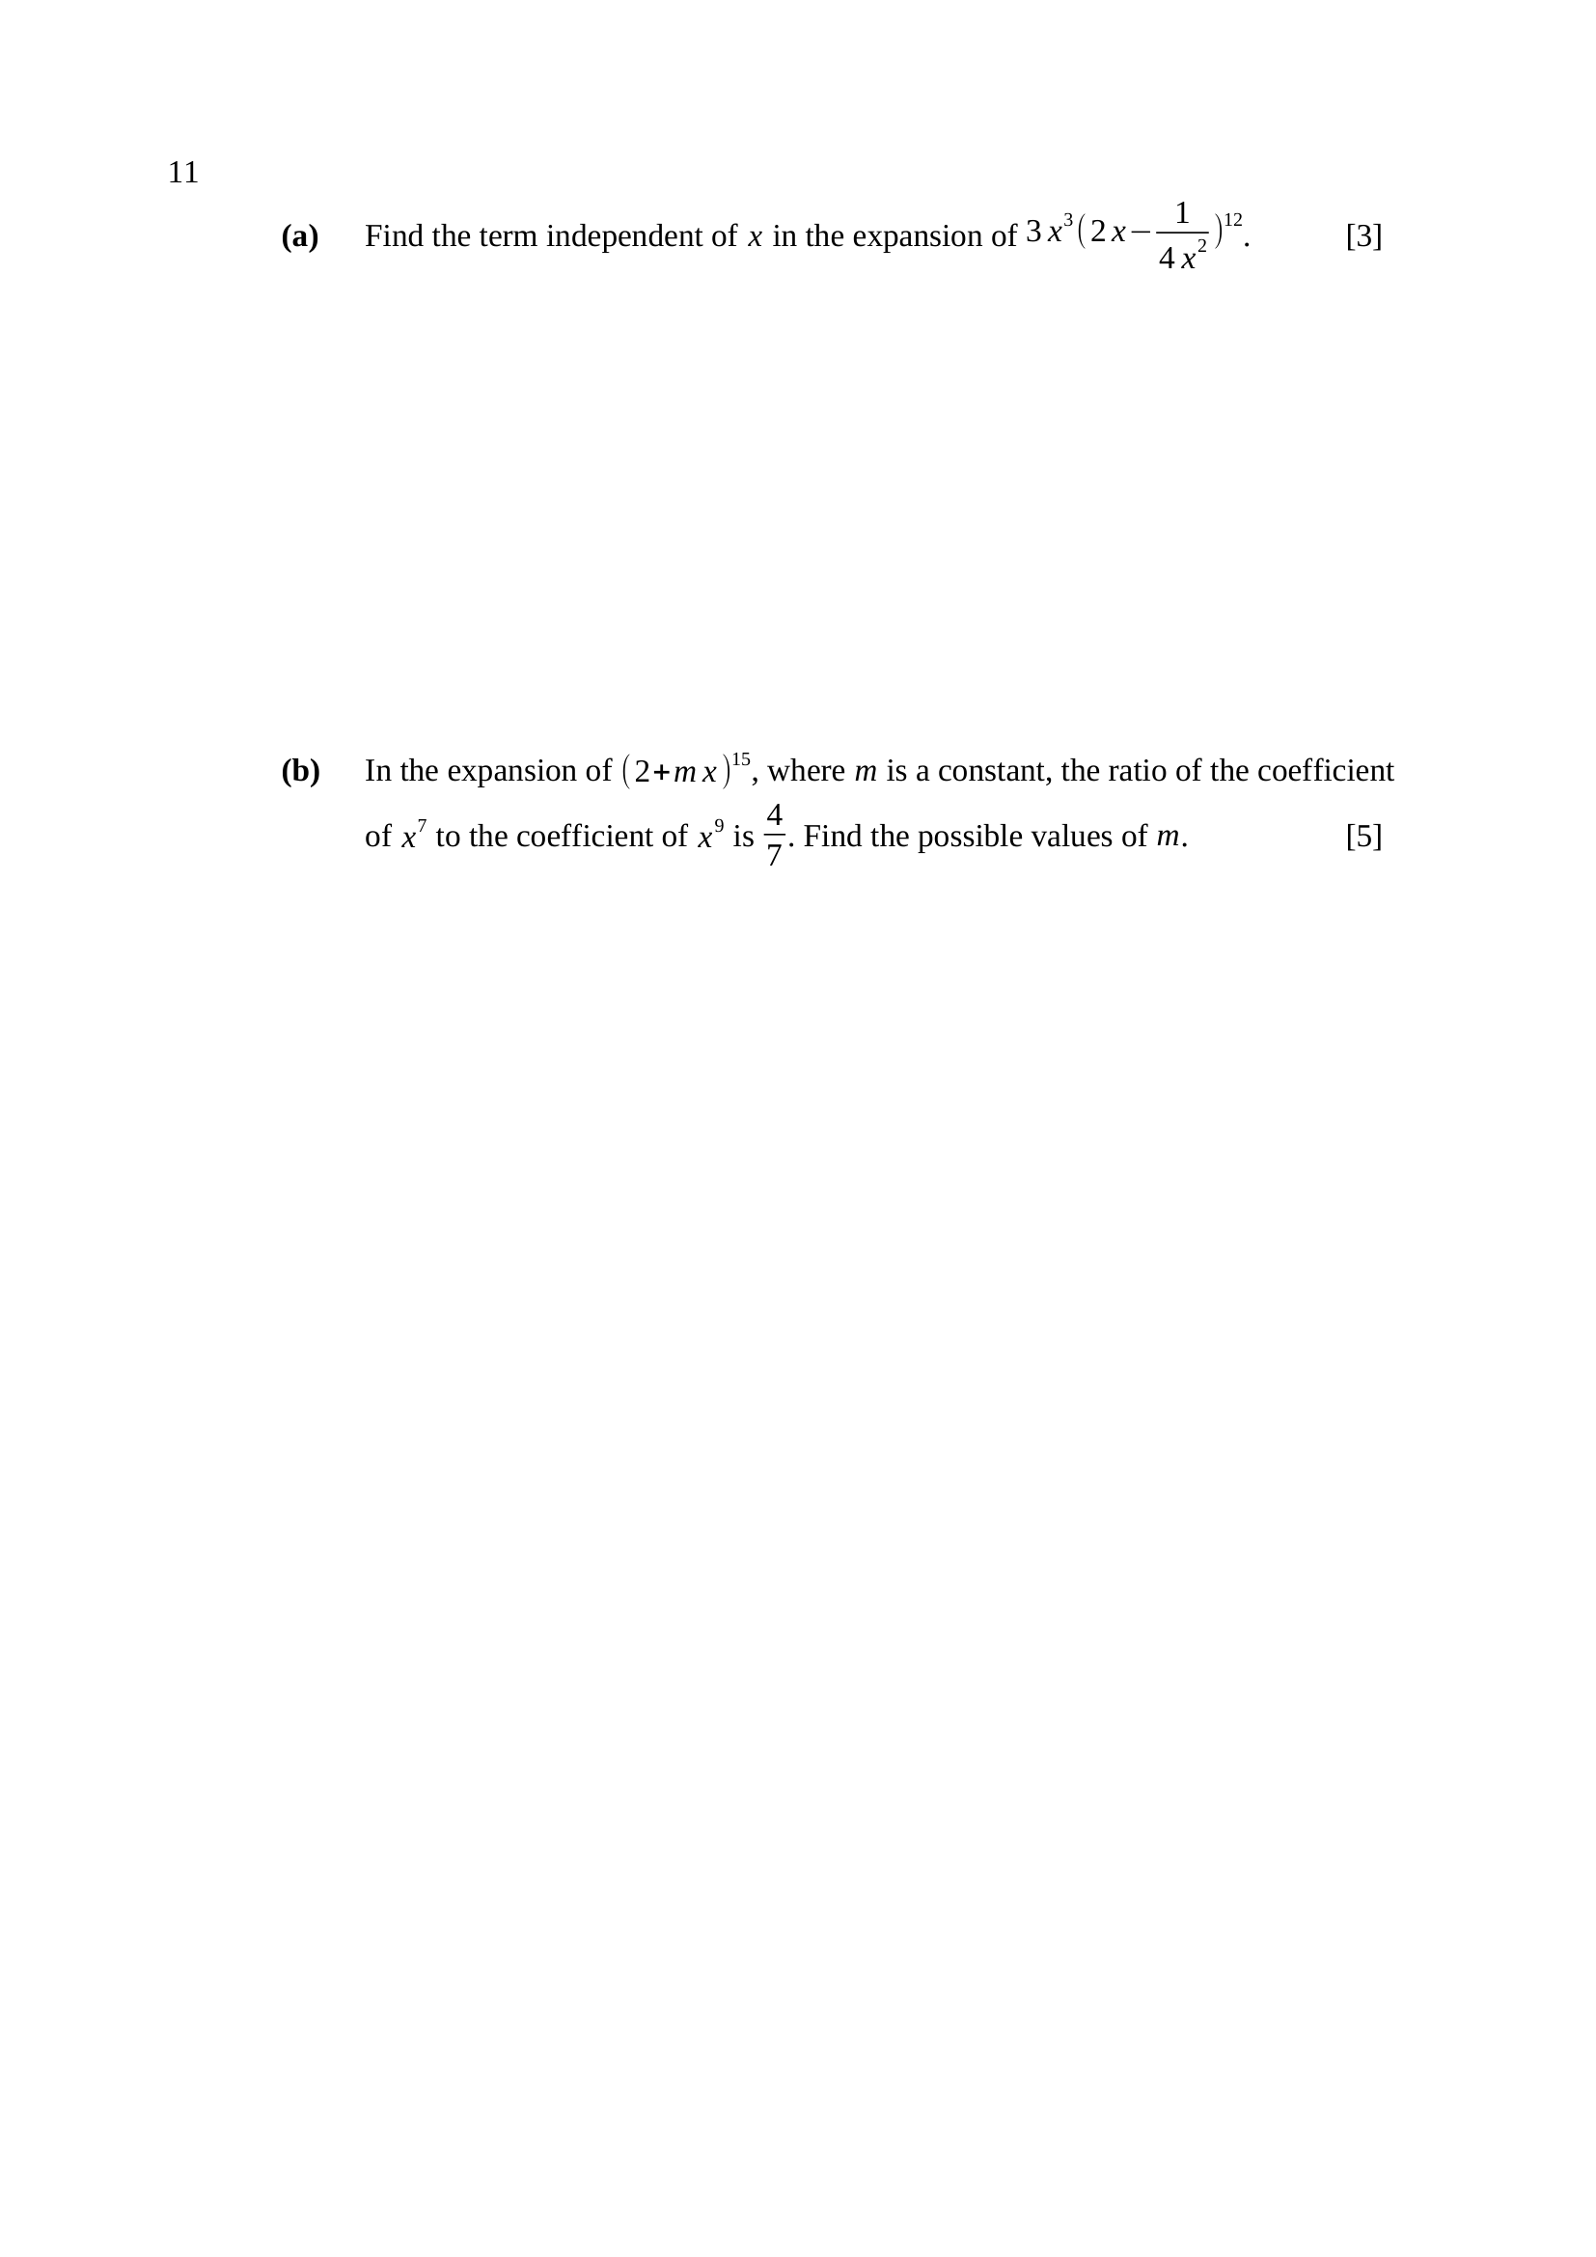
general term of ${\left(2x − \frac{1}{4x^{2}}\right)}^{12}$:
$({12 \atop r})(2x)^{12−r}{\left( − \frac{1}{4x^{2}}\right)}^{r}$
$\text{i.e. }({12 \atop r})2^{12−r}(−1)^{r}4^{−r}x^{12−3r}$
with $3x^{3}$ the power of $x$ is $3+12−3r=15−3r$
$15−3r=0⇒r=5$
$\text{term}=3({12 \atop 5})2^{7}(−1)^{5}4^{−5}$
$\text{term}=3×792×\frac{128}{1024}×(−1)$
$∴\text{term}=−297$
Key concept: write the GENERAL term, then set the power of $x$ to zero.
M1 – general term $({12 \atop r})(2x)^{12−r}{\left( − \frac{1}{4x^{2}}\right)}^{r}$
M1 – $15−3r=0$ giving $r=5$
A1 – $−297$
Trap – ${\left(−1\right)}^{5}$ makes it negative; $({12 \atop 5})=792$ and $\frac{128}{1024}=\frac{1}{8}$.
coefficient of $x^{7}$: $({15 \atop 7})2^{8}m^{7}$
coefficient of $x^{9}$: $({15 \atop 9})2^{6}m^{9}$
$\frac{({15 \atop 7})2^{8}m^{7}}{({15 \atop 9})2^{6}m^{9}}=\frac{4}{7}$
$\frac{6435}{5005}=\frac{9}{7}$, so $\frac{9}{7}×\frac{4}{m^{2}}=\frac{4}{7}$
$\frac{36}{7m^{2}}=\frac{4}{7}$
$m^{2}=9$
$∴m=3$ or $m=−3$
M1 – coefficient of $x^{7}$ as $({15 \atop 7})2^{8}m^{7}$
M1 – coefficient of $x^{9}$ as $({15 \atop 9})2^{6}m^{9}$
M1 – ratio formed and equated to $\frac{4}{7}$
M1 – simplified to $m^{2}=9$
A1 – $m=±3$
Trap – both signs are needed — the ratio depends on $m^{2}$.

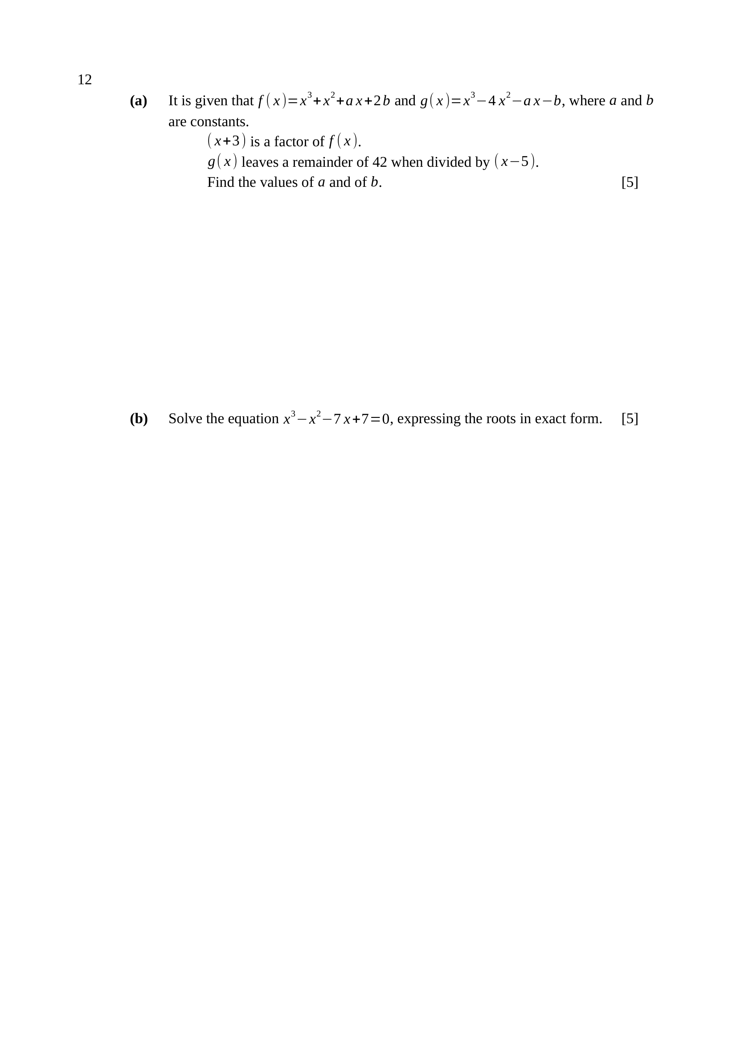
$\left(x + 3\right)$ a factor $⇒f(−3)=0$
$−27+9−3a+2b=0$
$2b=3a+18$ …(1)
$g(5)=42$: $125−100−5a−b=42$
$b=−5a−17$ …(2)
(2) into (1): $2(−5a−17)=3a+18$
$−13a=52$
$∴a=−4, b=3$
M1 – $f(−3)=0$ used
A1 – $2b=3a+18$
M1 – $g(5)=42$ used
A1 – $b=−5a−17$
A1 – $a=−4$ and $b=3$
Trap – $\left(−3)^{3}=−27\right.$ and $\left(−3)^{2}=9\right.$; a fractional $a$ is the signal of a slip.
$x^{3}−x^{2}−7x+7=0$
$x^{2}(x−1)−7(x−1)=0$
$(x−1)\left(x^{2} − 7\right)=0$
$x^{2}=7$
$∴x=1, x=\sqrt{7}, x=−\sqrt{7}$
M1 – grouping, or the factor theorem with $x=1$
A1 – $(x−1)\left(x^{2} − 7\right)$
M1 – $x^{2}=7$ solved
A1 – $x=1$
A1 – $x=±\sqrt{7}$
Trap – exact form means $±\sqrt{7}$, not $±2.65$.

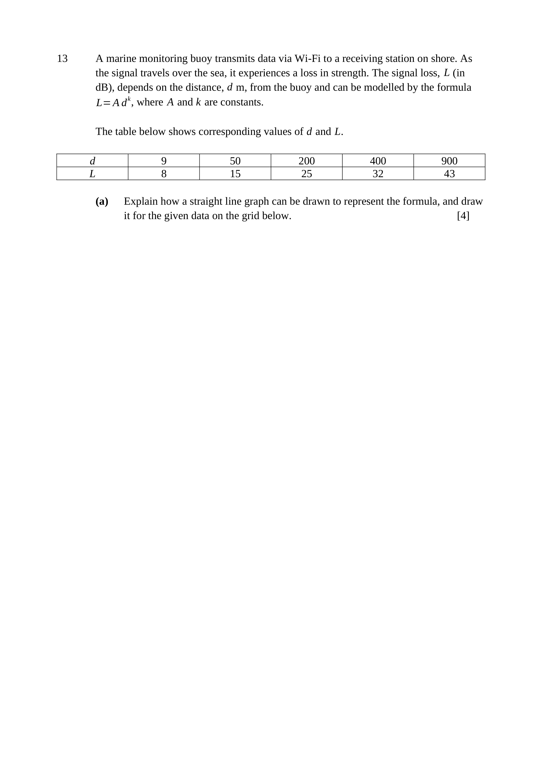
$L=Ad^{ k}$
$lgL=lgA+klgd$
$lgL=klgd+lgA$
Comparing with $Y=mX+c$: plot $lgL$ (vertical) against $lgd$ (horizontal).
The graph is a straight line of gradient $k$ and vertical intercept $lgA$.
$lgd$: $0.954, 1.699, 2.301, 2.602, 2.954$
$lgL$: $0.903, 1.176, 1.398, 1.505, 1.633$
Key concept: take logs of both sides to linearise a power law.
B1 – $lg$ taken of both sides: $lgL=lgA+klgd$
B1 – compares with $Y=mX+c$; gradient $k$, intercept $lgA$
M1 – both $lg$ rows computed
A1 – points plotted correctly and a straight line drawn


gradient $k=\frac{1.633−0.903}{2.954−0.954}=\frac{0.730}{2.000}$
$k≈0.365$
intercept: $lgA=lgL−klgd$
$lgA=0.903−0.365(0.954)=0.555$
$A={10}^{0.555}$
$∴A≈3.59, k≈0.365$
Key concept: read two points off the DRAWN LINE, as far apart as it allows.
M1 – gradient from two points on the line
A1 – $k≈0.365$
M1 – intercept used to find $lgA$
A1 – $A≈3.59$
Note – accept $k$ from $0.35$ to $0.38$ and $A$ from $3.3$ to $3.9$.
Note – check: $3.59×{200}^{0.365}≈24.8$ against the tabulated $L=25$.

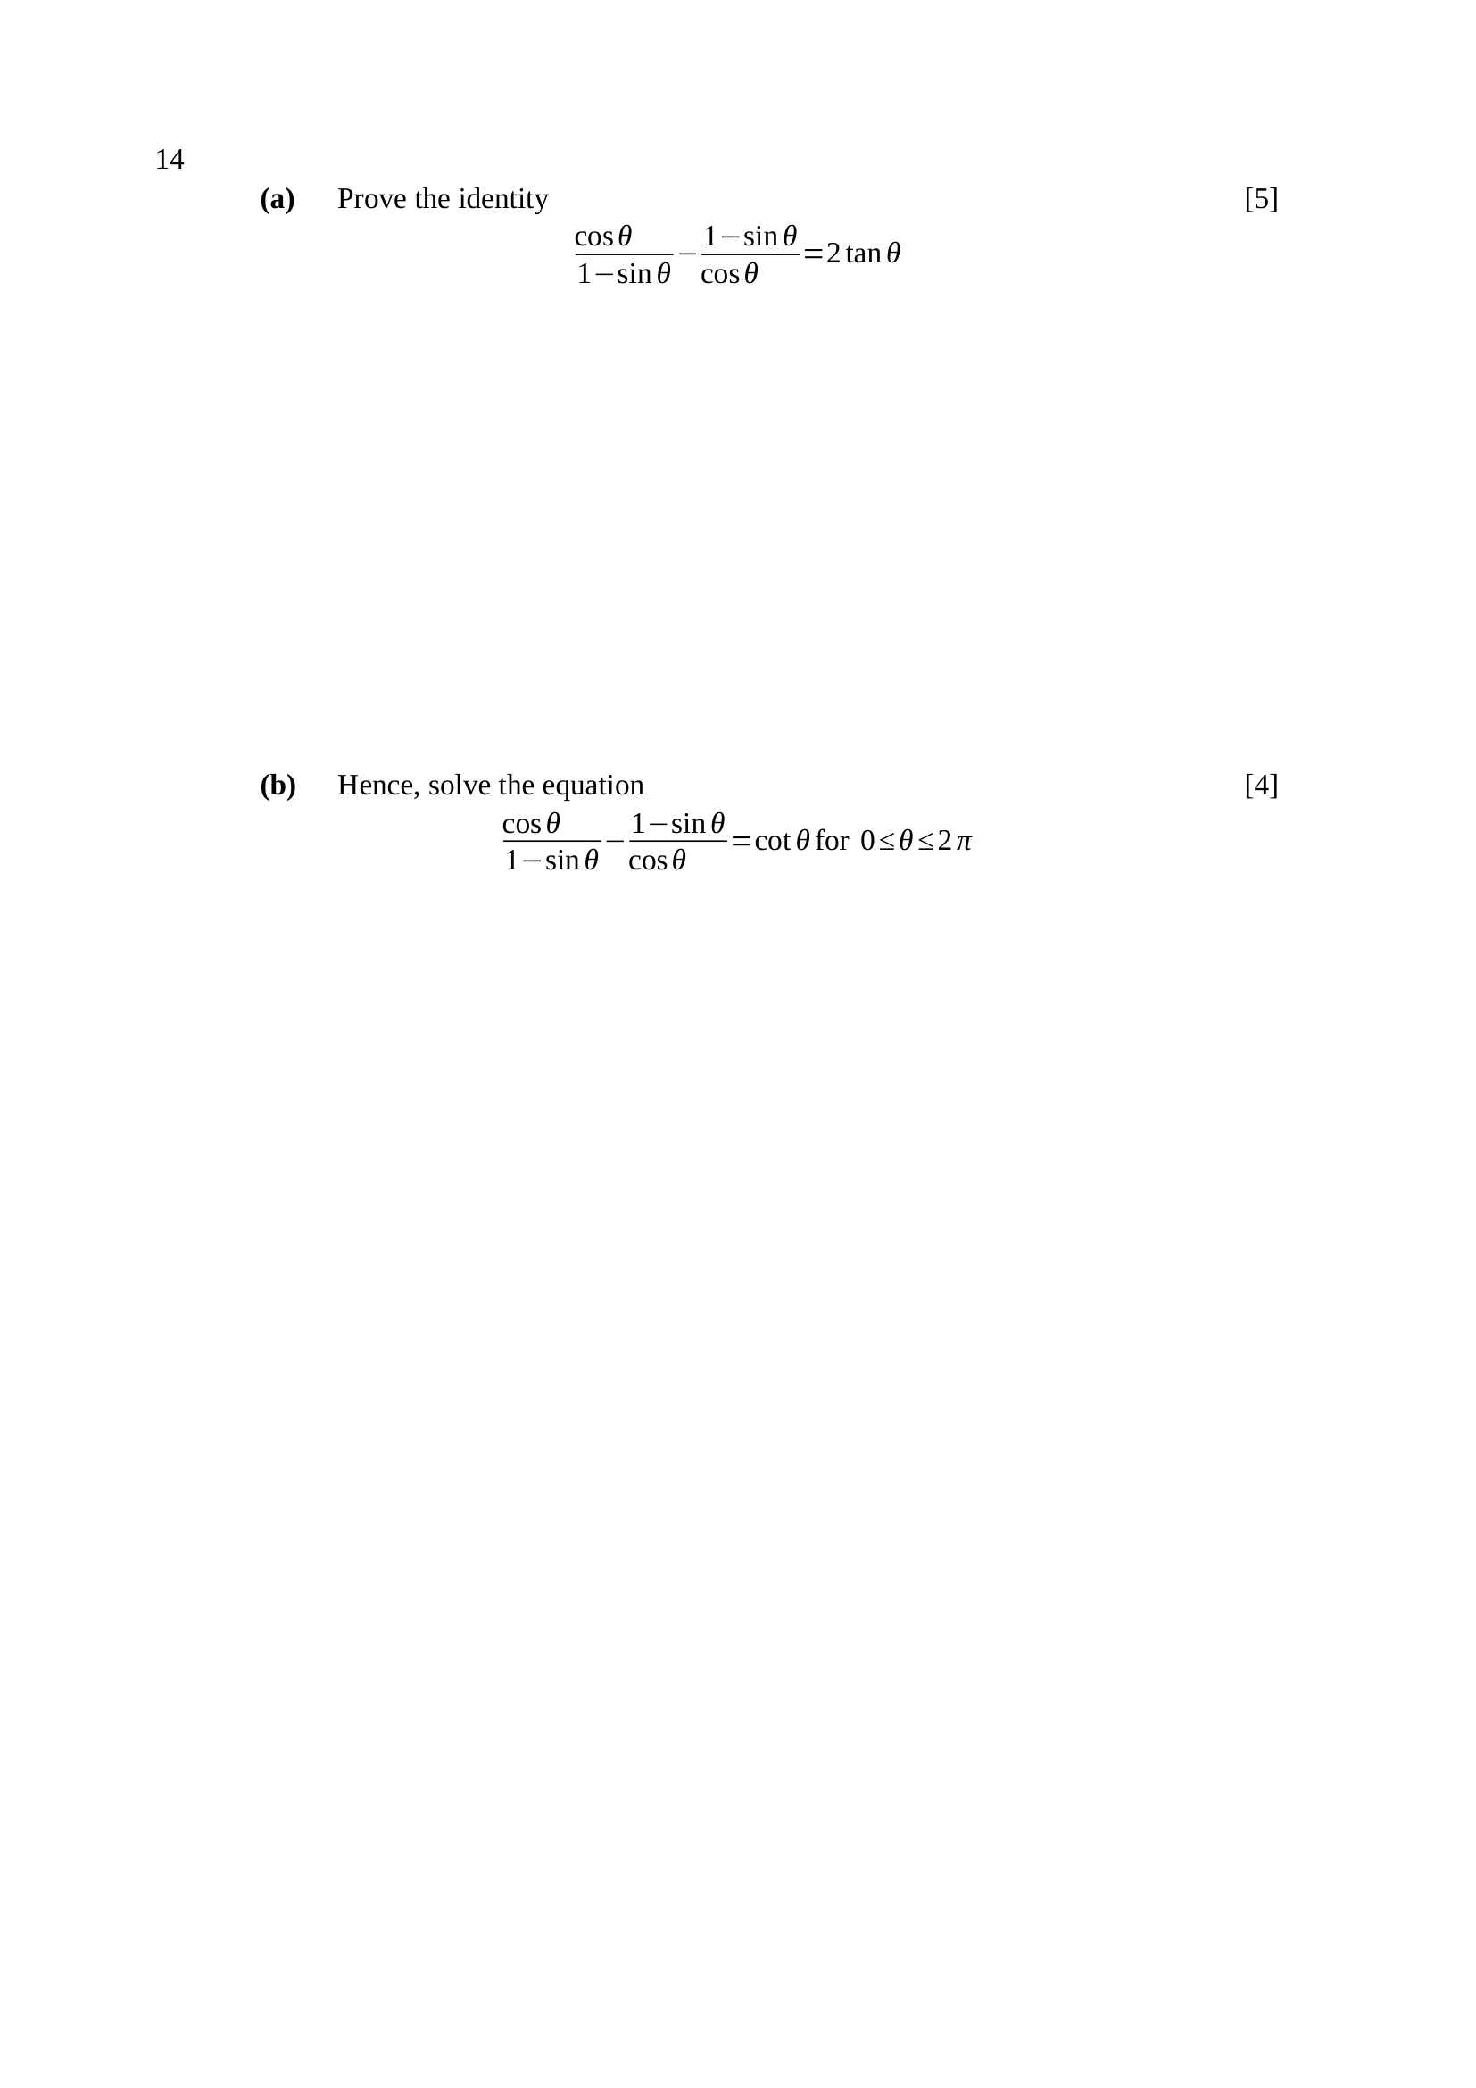
$\text{LHS}=\frac{\cos^{2}θ−(1−sinθ)^{2}}{(1−sinθ)cosθ}$
$\left(1−sinθ)^{2}=1−2sinθ+\sin^{2}θ\right.$
$\text{numerator}=\cos^{2}θ−1+2sinθ−\sin^{2}θ$
using $\cos^{2}θ=1−\sin^{2}θ$:
$\text{numerator}=2sinθ−2\sin^{2}θ=2sinθ(1−sinθ)$
$\text{LHS}=\frac{2sinθ(1−sinθ)}{(1−sinθ)cosθ}=\frac{2sinθ}{cosθ}$
$\text{LHS}=2tanθ=\text{RHS}$
Key concept: one common denominator, then $\cos^{2}θ=1−\sin^{2}θ$.
M1 – single fraction $\frac{\cos^{2}θ−(1−sinθ)^{2}}{(1−sinθ)cosθ}$
M1 – ${\left(1−sinθ\right)}^{2}$ expanded
M1 – $\cos^{2}θ$ replaced by $1−\sin^{2}θ$
M1 – numerator factorised as $2sinθ(1−sinθ)$
A1 – cancels to $2tanθ$
Trap – combining as $\frac{cosθ−(1−sinθ)}{cosθ(1−sinθ)}$ — the numerators must be cross-multiplied.
by (a): $2tanθ=cotθ=\frac{1}{tanθ}$
$2\tan^{2}θ=1$
$tanθ=±\frac{1}{\sqrt{2}}$
basic angle $α=0.6155$ rad
$tanθ>0$: $θ=0.6155, π+0.6155=3.757$
$tanθ<0$: $θ=π−0.6155=2.526, 2π−0.6155=5.668$
$∴θ=0.615, 2.53, 3.76, 5.67$ rad
M1 – result of (a) used: $2tanθ=cotθ$
M1 – $\tan^{2}θ=\frac{1}{2}$
A1 – two correct values
A1 – all four values, in radians to $3$ s.f.
Trap – the range $0≤θ≤2π$ is in radians — degrees score at most 3.

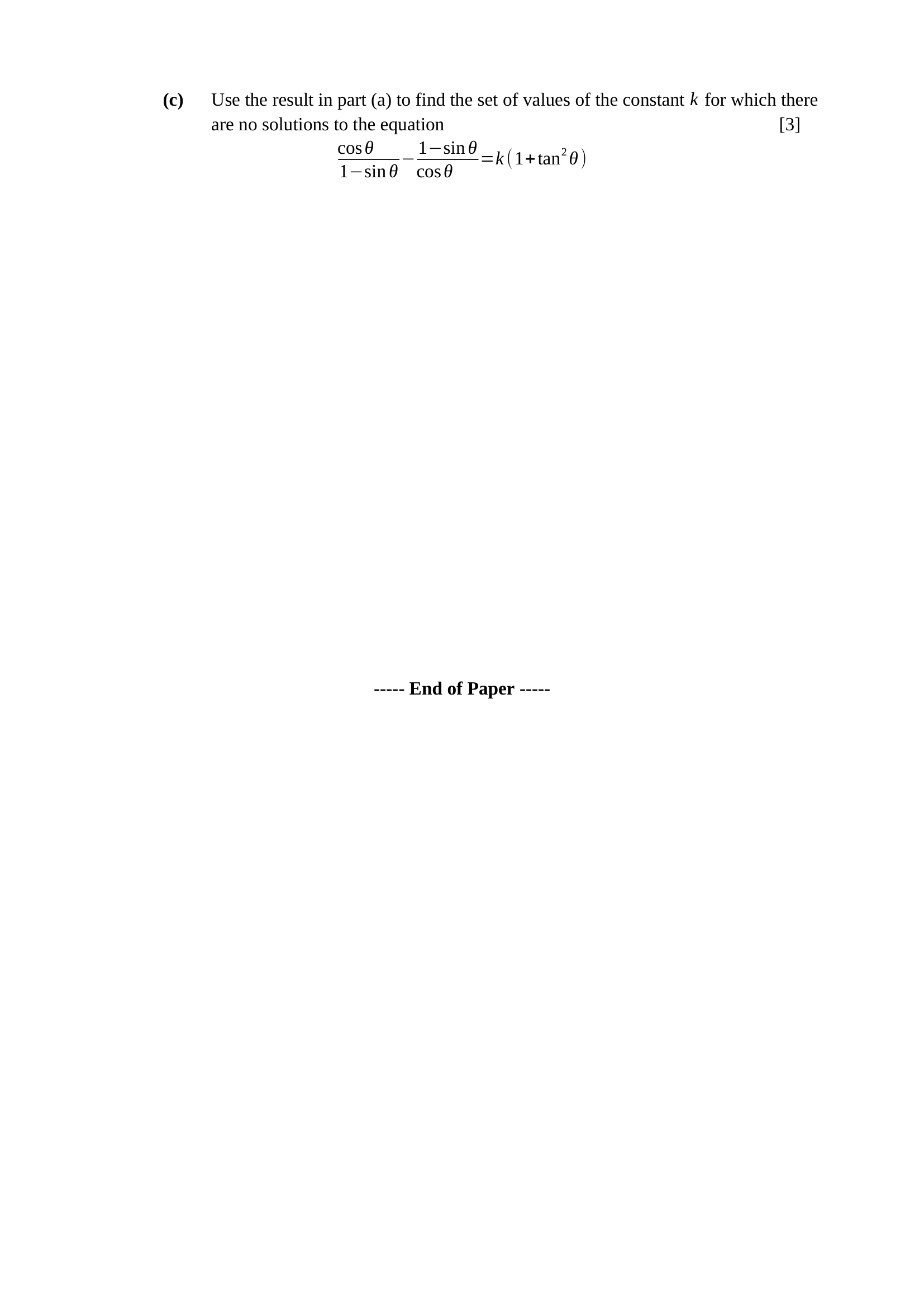
by (a) the equation becomes $2tanθ=k\left(1 + \tan^{2}θ\right)$
let $t=tanθ$:
$kt^{2}−2t+k=0$
no real $t$ needs $\text{discriminant}<0$
$(−2)^{2}−4(k)(k)<0$
$4−4k^{2}<0$
$k^{2}>1$
$∴k<−1$ or $k>1$
Key concept: the identity turns it into a quadratic in $tanθ$.
M1 – $kt^{2}−2t+k=0$ with $t=tanθ$
M1 – $\text{discriminant}<0$ used
A1 – $k<−1$ or $k>1$, i.e. $k^{2}>1$
Note – $k=0$ gives $t=0$, which does have solutions — consistent, since $0^{2}<1$.

